Ryerson University

|  |  |
| --- | --- |
| Course Number | CPS 125 |
| Course Title | Digital Computation and Coding |
| Semester/Year | Winter 2019 |
| Instructor | Dr. Panar |
| TA Name | N/A |

|  |  |
| --- | --- |
| Lab/Tutorial Report No. | Final |

|  |  |
| --- | --- |
| Report Title | Temperature Analysis of the Great Lakes |

|  |  |
| --- | --- |
| Section No. | 11 + 13 |
| Group No. | N/A |
| Submission Date | 4/8/2019 |
| Due Date | 4/8/2019 |

|  |  |  |
| --- | --- | --- |
| Student Name | Student ID | Signature (or initials)* |
|  | Format: xxxx12345 |  |
| Korbin Mallette | xxxx75563 | KM |
| Lucas Church | xxxx88754 | LC |
| Jules Gammad | xxxx74689 | JG |
|  |  |  |

(Note: remove the first 4 digits from your student ID)

*\*By signing or initialing above you attest that you have contributed to this submission and confirm that all work you have contributed to this submission is your own work. Any suspicion of copying or plagiarism in this work will result in an investigation of Academic Misconduct and may result in a “0” on the work, an “F” in the course, or possibly more severe penalties, as well as a Disciplinary Notice on your academic record under the Student Code of Academic Conduct, which can be found online at:*

[*http://www.ryerson.ca/content/dam/senate/policies/pol60.pdf*](http://www.ryerson.ca/content/dam/senate/policies/pol60.pdf)

**Temperature Analysis of the Great Lakes**

## **Introduction**

The Great lakes, located in central North America, are some of the largest bodies of freshwater on the planet. These massive lakes, primarily in Ontario, make up large reservoirs of the world’s fresh water. These five lakes: Superior, Michigan, Huron, Erie, and Ontario (See Right), are vital pieces of the global ecosystem, and are necessary for maintaining the ecological homeostasis of the planet as a whole. This study also monitors the temperature changes of Lake St. Clair, which is another large freshwater lake located in Ontario. Monitoring the various physical and chemical states and properties of these bodies of water will allow for a better understanding and grasp on the overall health and stability of their ecosystems. 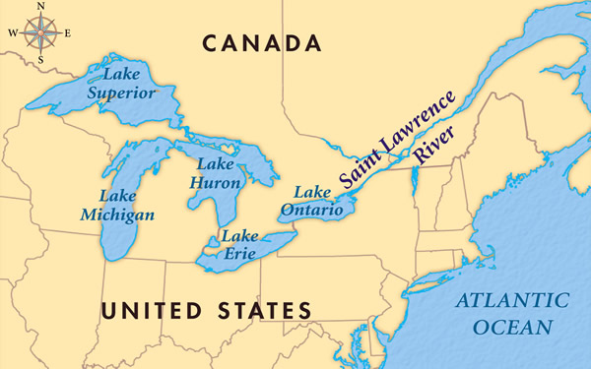

Obviously throughout the year, and with the changing seasons, there will be a wide variation in temperature ranges following an averaging cooling in the winter months and a warming in the summer months; however, apart from this, the changing of internal temperatures of these lakes can be telling of a large variety of ecological effects that humans impose on it. Everything from waste water and refinery pollutants to increased fertilizer and road salt usage can alter the physical and chemical properties of these bodies of water.

Lake St. Clair is a smaller lake located between Lake Huron and Lake Erie (See Left) in Ontario. This lake is another freshwater lake and because it is not a massive freshwater reservoir like the other five great lakes, it works as an excellent reference point for the effects of the seasons and temperature on smaller, more average sized lakes, while still keeping the geographical location relatively constant.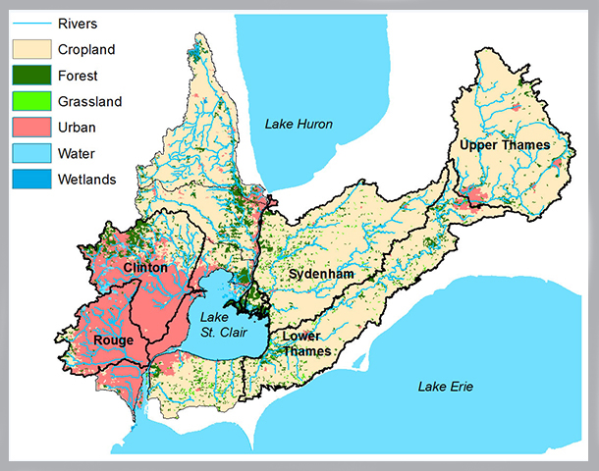

## **Evaluation of Temperature Differentiation**

1. Yearly Averages and Total Average

The average yearly temperatures of the various lakes that are being evaluated are highly dependant on its geographical location as well as a variety of geographical features of importance. Being the most northern of the lakes Lake Superior has the lowest average yearly temperature of 6.92°C (Appendix 1, Function 1) and this continues to hold true for the rest of the other five lakes. The further south that the lakes are, the warmer their average temperatures. In other cases, the latitude is not the only factor that can affect the average yearly temperatures such as distance from larger bodies such as ocean and lakes as well as the geological position, be it on top of tectonic plates overlaps or magma reservoirs. These geological features and geographical differences will affect these lakes to a much less extent in relation to each other because in global terms the lakes are very close together.



[Geographic and Latitudinal Locations of Great Lakes and St.Clair lake]

1. Coldest and Warmest Average Temperatures

While all of the lakes only differ by a few average degrees, especially Lake Erie, Ontario and St. Clair, it is clear that Erie is the warmest of all of the lakes with an average temperature of 11.95°C (Appendix 1, Function 2). This temperature follows the expected trend of the relationship of displacement along the longitudinal lines perpendicular to the equator and the change of temperature. Following this trend, Lake Superior has the lowest average temperature. The average temperature of the six separate bodies of water is 10.24°C. This means that in relation to the values calculated in the previous section (Appendix 1, Function 1) the following lakes are considered higher than the average: Lake Erie, St. Clair, and Ontario. The following lakes have a lower than average temperature: Superior, Huron and Michigan. The only discrepancy with these values is Lake Michigan which has an average line lower than Lake Ontario. However, this can also be due to the fact that there could be a large depth the more north which would increase the overall heat capacity, and increasing the time that it takes for the lake to heat up. By looking at the average temperatures, it is clear that the geographic location is the most important feature in determining the average yearly temperatures.

1. Absolute Coldest and Warmest Days per Lake

The ranges of temperatures observed throughout the year ranges heavily, and of course, is directly due to the time of year. The following graph shows how each of the separate lakes vary in relation to the time of the year (See Left). From this graph and the code used to find the minimums and maximums the warmest temperatures between the six different lakes ranges somewhere between around 180 - 280 days into the year, lining up with the summer months which are both hotter as well as have large refinery productions dumping hot water into the rivers and lakes that feed into these lakes especially Lake Ontario that Toronto is on as well as Kingston.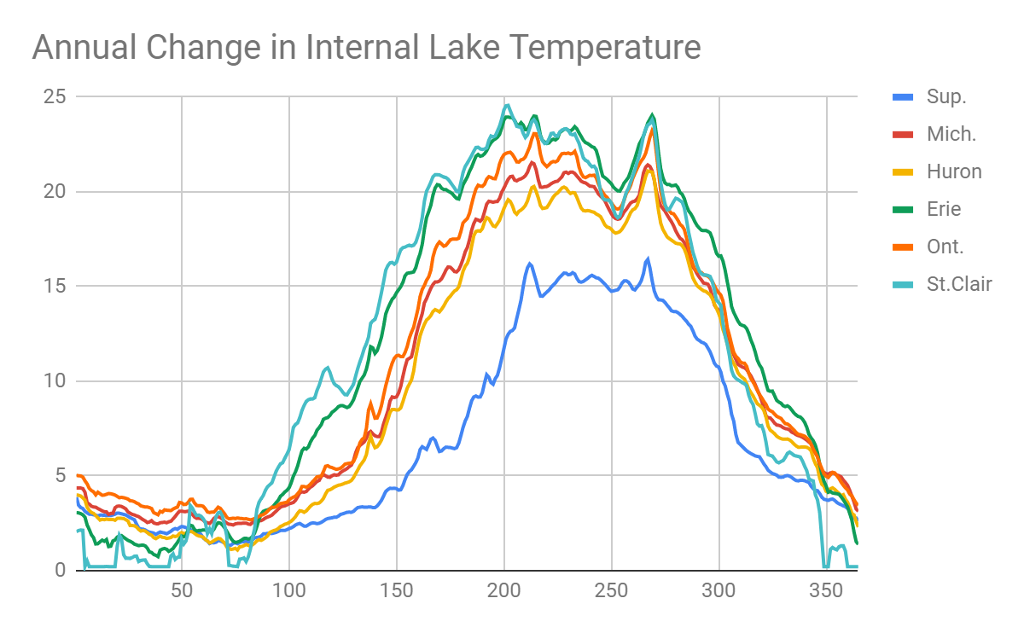

1. Absolute Coldest and Warmest Day Total

The warmest and coldest temperature was achieved by Lake St. Clair, the smallest body of water. On July 21st Lake St. Clair achieved a temperature of 24.56°C and on a multiple dates Lake St. Clair reached a low of 0.21°C. The reason for Lake St. Clair achieving the highest and the lowest temperature is not because of its geographical location but because of its lower heat capacity in comparison to the other lakes. With a much smaller amount of water in comparison to the great lakes, Lake St. Clair is able to heat and cool much faster than the others, causing a wider range of the other lakes.

1. + 6. Seasonal Averages

Over the summer and the winter months, the temperatures will average higher or lower respectively due to the external weather conditions, however, it does not mean that the averages for these seasons will reflect the yearly averages of the separate bodies. The values, rated from highest to lowest, are not equal between the seasons. While Lake Superior had the coldest summer temperatures out of all the Lakes, it had the third highest average temperatures in the winter season. The values and the order of the averages during the winter and the summer seasons can be seen below. The values do not seem to follow a distinct pattern, however, the lakes that had very low averages do contain much cooler summer temperatures even if they could have a relatively, in comparison to the other lakes’ higher winter temperatures.



While these values do not seem to follow the previous patterns due to geographical and geological reasons, they do follow the averages that we collected earlier by having a large variation in the winter and summer temperatures.

1. Number of Swimmable Days Yearly

One of the main attractions of the great lakes is the summer months when it can be good weather to go swimming. An internal temperature of anything larger than 20.00°C can be considered a reasonable temperature to go swimming in. All of the lakes, excluding Lake Superior, contain a varying number of warm days. Lake Michigan had 52, Huron had 14, Lake Erie had 108, Lake Ontario had 75 and Lake St. Clair had 98. Lake Superior was the only lake not to have any days that had a temperature above 20 degrees throughout the entire year which makes sense as its average high was 13.03°C. These values appear to make sense as they follow the exact same order as the average summer temperatures by lake (See Above). This will make sense as the only time that any of these lakes have the chance of getting warm enough is during the summer months. However, while these values do make sense this is also primarily on Canadian soil so the chances are there will be people swimming nearly double the calculated number of days, the cold does not stop Canadians (1).

1. Number of Days with Freezing Weather

Due to the Great Lakes being so massive, the sheer amount of volume cannot freeze through the cold weather of one day meaning that the entire body of water will not drop below 0°C ever, the flow of water both in and out of the lakes also contributes to this effect. This observation is reflected by the calculated values (Appendix 1, Function 8). At no point during the year will there be any 0°C internal temperatures for any of the Great Lakes or for Lake St. Clair.

## **Conclusion**

While each of the Great Lakes possesses an entirely unique ecosystem, certain trends can still be determined based on geographical and ecological parameters. Effects such as lake run-off from rainwater and inflow or outflow of water to other freshwater systems can greatly affect the physical composition and properties of the lake. As far as observable properties determined by analyzing this data, we can see that the two largest factors that contribute to temperature trends in the Great Lakes are size and latitude.

The team’s experience was largely a positive one, with the coding and report going smoothly. What would be done different should a similar project be taken on, would be a primary discussion on how each of the functions will work, so that implementation in the total production was smoother. Our team ran into trouble when the output of some functions were unusable as input for others, leading to a couple of functions needing to be redone. A mutual agreement of function integration early in the project would have prevented this from happening.

**Distribution of Duties:**

**Korbin Mallete:** Functions 1-3, Report write-up

**Jules Gammad:** Functions 4-6, Coding assistance

**Lucas Church:** Functions 7&8, Read-in function (main), Report write-up

**Reference:**

1. G. Yarn, “12 Most Canadian things to do this winter!,” *Family Fun Canada*, 17-Jan-2018. [Online]. Available: https://www.familyfuncanada.com/12-canadian-things-winter/. [Accessed: 08-Apr-2019].

**Appendix A: C Code**

#include <stdio.h>

#include <math.h>

#include <string.h>

char lakenames[6][9];

double lake_ave[2][6];

double lake_warmest[3][6];

double lake_coldest[3][6];

int coldest_days[365];

double overall_avg;

void swap (double *arr1, double *arr2) {

double temp = *arr1;

*arr1 = *arr2;

*arr2 = temp;

}

void convert_date(int date) {

if(date <= 59 && date > 0) {

if (date <= 31) {

printf("On 01/%-.2d ", date);

}

else{

printf("On 02/%-.2d ", date-31);

}

}

else if (date > 59) {

if(date <= 90)

printf("On %-.2d/%-.2d ", (int)ceil(date/30.41), date-59);

else if(date <= 120)

printf("On %-.2d/%-.2d ", (int)ceil(date/30.41), date-90);

else if(date <= 151)

printf("On %-.2d/%-.2d ", (int)ceil(date/30.41), date-120);

else if(date <= 181)

printf("On %-.2d/%-.2d ", (int)ceil(date/30.41), date-151);

else if(date <= 212)

printf("On %-.2d/%-.2d ", (int)ceil(date/30.41), date-181);

else if(date <= 243)

printf("On %-.2d/%-.2d ", (int)ceil(date/30.41), date-212);

else if(date <= 273)

printf("On %-.2d/%-.2d ", (int)ceil(date/30.41), date-243);

else if(date <= 304)

printf("On %-.2d/%-.2d ", (int)ceil(date/30.41), date-273);

else if(date <= 334)

printf("On %-.2d/%-.2d ", (int)ceil(date/30.41), date-304);

else if(date < 365)

printf("On %-.2d/%-.2d ", (int)ceil(date/30.41), date-334);

else if (date == 365)

printf("On %-.2d/%-.2d ", (int)floor(date/30.41), date-334);

}

}

void call_lakename(double lake_counter) {

if (lake_counter == 0.0)

printf("Lake %s ",lakenames[0]);

else if (lake_counter == 1.0)

printf("Lake %s ",lakenames[1]);

else if (lake_counter == 2.0)

printf("Lake %s ",lakenames[2]);

else if (lake_counter == 3.0)

printf("Lake %s ",lakenames[3]);

else if (lake_counter == 4.0)

printf("Lake %s ",lakenames[4]);

else if (lake_counter == 5.0)

printf("Lake %s ",lakenames[5]);

}

double func_1 (double data[365][8], char label[6][9]) {

int day = 0;

int count = 0, i=0;

double day_temp, avg = 0.0;

for (count = 2; count < 8; count++) {

lake_ave[0][count-2] = (count-2)*1.0;

for(day = 0; day < 365; day++) {

day_temp = data[day][count];

avg = day_temp + avg;

}

lake_ave[1][count-2] = avg/365;

printf("Average Temperature for Lake %s is %.2lf Celsius\n", label[count-2], lake_ave[1][count-2]);

avg = 0.0;

}

for(i = 0; i < 6; i++) {

overall_avg = lake_ave[1][i] + overall_avg;

}

overall_avg = overall_avg/6.0;

printf("Overall A\average of all the lakes is %.2lf Celsius\n", overall_avg);

}

void func_2 (double data[365][8], char label[6][9]) {

int i, x;

for (x = 0; x < 5; x++) {

for(i = 0; i < 5-x; i++) {

if(lake_ave[1][i] > lake_ave[1][i+1]) {

swap(&lake_ave[1][i], &lake_ave[1][i+1]);

swap(&lake_ave[0][i], &lake_ave[0][i+1]);

}

}

}

call_lakename(lake_ave[0][5]);

printf("has the warmest average temperature at %.2lf Celsius\n", lake_ave[1][5]);

call_lakename(lake_ave[0][0]);

printf("has the coldest average temperature at %.2lf Celsius\n", lake_ave[1][0]);

for (i = 0; i < 6; i++) {

if(lake_ave[1][i] > overall_avg) {

printf("Lake %s is above the average\n", label[i]);

}else {

printf("Lake %s is below the average\n", label[i]);

}

}

}

void func_3 (double lake_data[365][8], char label[6][9]) {

int x,i;

double coldest, warmest;

for (i = 0; i <365; i++) {

coldest_days[i] = 0;

}

for (x = 2; x < 8; x++) {

lake_warmest[0][x-2] = 1.0*(x-2);

lake_coldest[0][x-2] = 1.0*(x-2);

coldest = lake_data[0][x];

warmest = lake_data[0][x];

for (i = 0; i < 365; i++) {

if (warmest < lake_data[i][x]) {

warmest = lake_data[i][x];

lake_warmest[2][x-2] = i+1;

}

if (coldest > lake_data[i][x]) {

coldest = lake_data[i][x];

lake_coldest[2][x-2] = i+1;

}

/*

lists all the coldest dates for St. Clair

*/

if(lake_data[i][x] == 0.21) {

coldest_days[i] = i+1;

}

}

lake_warmest[1][x-2] = warmest;

lake_coldest[1][x-2] = coldest;

}

for (i = 0; i < 6; i++) {

convert_date(((int)lake_warmest[2][i]));

printf("Lake %s acquired an overall warmest temperature of %.2lf Celsius\n",label[i], lake_warmest[1][i]);

convert_date(((int)lake_coldest[2][i]));

printf("it acquired an overall coldest temperature of %.2lf Celsius\n", lake_coldest[1][i]);

}

}

void func_4(double lake_data[365][8]) {

int i, x;

for (x = 0; x < 5; x++) {

for(i = 0; i < 5-x; i++) {

if(lake_warmest[1][i] > lake_warmest[1][i+1]) {

swap(&lake_warmest[1][i], &lake_warmest[1][i+1]);

swap(&lake_warmest[0][i], &lake_warmest[0][i+1]);

}

if(lake_coldest[1][i] > lake_coldest[1][i+1]) {

swap(&lake_coldest[1][i], &lake_coldest[1][i+1]);

swap(&lake_coldest[0][i], &lake_coldest[0][i+1]);

}

}

}

convert_date(((int)lake_warmest[2][5]));

printf("The lake that acquired the warmest overall temperature is ");

call_lakename(lake_warmest[0][5]);

printf("at %.2lf Celsius\n", lake_warmest[1][5]);

printf("The lake that acquired coldest overall temparature is ");

call_lakename(lake_coldest[0][0]);

printf("at %.2lf Celsius\n", lake_coldest[1][0]);

printf("The coldest temperature was acquired on these dates: \n");

for( i = 0; i < 365; i++) {

if (coldest_days[i] != 0) {

convert_date(coldest_days[i]);

printf(", ");

}

}

printf("\n");

}

void func_5(double lake_data[365][8]) {

double sum;

double summer_average[2][6];

int x,i;

for (x = 2; x < 8; x++) {

sum = 0.0;

summer_average[0][x-2] = 1.0*(x-2);

for(i = 171; i < 265; i++) {

sum += lake_data[i][x];

}

summer_average[1][x-2] = sum/(1.0*(94));

}

for (x = 0; x < 5; x++) {

for(i = 0; i < 5-x; i++) {

if(summer_average[1][i] > summer_average[1][i+1]) {

swap(&summer_average[1][i], &summer_average[1][i+1]);

swap(&summer_average[0][i], &summer_average[0][i+1]);

}

}

}

printf("The summer average for all 6 lakes listed from warmest to coldest are:\n");

for(i = 5; i >= 0; i--) {

call_lakename(summer_average[0][i]);

printf("at %.2lf Celsius\n", summer_average[1][i]);

}

}

void func_6(double lake_data[365][8]) {

double sum;

double sum2;

double winter_average[2][6];

int x,i;

for (x = 2; x < 8; x++) {

sum = 0.0;

sum2 = 0.0;

winter_average[0][x-2] = 1.0*(x-2);

for(i = 0; i < 79; i++) {

sum += lake_data[i][x];

}

for(i = 354; i < 365; i++) {

sum2 += lake_data[i][x];

}

winter_average[1][x-2] = (sum+sum2)/(1.0*(90));

}

for (x = 0; x < 5; x++) {

for(i = 0; i < 5-x; i++) {

if(winter_average[1][i] > winter_average[1][i+1]) {

swap(&winter_average[1][i], &winter_average[1][i+1]);

swap(&winter_average[0][i], &winter_average[0][i+1]);

}

}

}

printf("The winter average for all 6 lakes listed from warmest to coldest are:\n");

for(i = 5; i >= 0; i--) {

call_lakename(winter_average[0][i]);

printf("at %.2lf Celsius\n", winter_average[1][i]);

}

}

void func_7(double data[365][8],char label[6][9])

{

int i,j,counter;

int freezedays[5];

int arrayvalue =0;

for (j=2;j<8;j++)

{

counter = 0;

for(i=0;i<365;i++)

{

if((data[i][0]) < 0)

{

counter++;

}

}

freezedays[j-2] = counter;

arrayvalue++;

}

printf("Days that the water was frozen (<0 degrees)\n");

for(j=0;j<6;j++)

{

printf("%4s:",label[j]);

printf("%5d\n",freezedays[j]);

}

}

void func_8(double data[365][8], char label[6][9])

{

int i,j,counter;

int warmdays[6];

for (j=2;j<8;j++)

{

counter = 0;

for(i=0;i<365;i++)

{

if(data[i][j] >= 20)

{

counter++;

}

}

warmdays[j-2] = counter;

}

printf("Days that the water was warm (>20 degrees)\n");

for(j=0;j<6;j++)

{

printf("%4s:",label[j]);

printf("%5d\n",warmdays[j]);

}

}

int main (){

FILE *data = fopen("data.txt","r");

double lakedata[365][8];

int i=0;

int j=0;

strcpy(lakenames[0], "Superior");

strcpy(lakenames[1], "Michigan");

strcpy(lakenames[2], "Huron");

strcpy(lakenames[3], "Erie");

strcpy(lakenames[4], "Ontario");

strcpy(lakenames[5], "St. Clair");

for(i=0;i<365;i++)

{

for(j=0;j<8;j++)

{

fscanf(data,"%lf",&lakedata[i][j]);

}

}

fclose(data);

/* THIS JUST DISPLAYS THE DATA */

/*

for(i=0;i<365;i++)

{

for(j=0;j<8;j++)

{

printf("%7.2lf ",lakedata[i][j]);

}

printf("\n");

}

*/

/* Function Calls*/

func_1(lakedata,lakenames);

printf("\n");

func_2(lakedata,lakenames);

printf("\n");

func_3(lakedata,lakenames);

printf("\n");

func_4(lakedata);

printf("\n");

func_5(lakedata);

printf("\n");

func_6(lakedata);

printf("\n");

func_7(lakedata,lakenames);

printf("\n");

func_8(lakedata,lakenames);

return(0);

}